# 1D, 2D, MultiDimensional Array Assignments

**Mandatory**

**1D Array**

1. Refer the code snippet and answer the queries

int main()

{

int array[100];

int *ptr;

// do something

}

Q1: Can pointer be used in Array-style syntax? e.g. ptr[10], ptr[0]

Ans-Yes it will print the address of the pointer but if check according to the above code to print the address of the array first we need assign the array to the pointer like eg. int *ptr=array.

Q2: Can Array be used in Pointer-style syntax? e.g. *array, *(array + 0), *(array + 10)

Ans-Yes gonna print the value of the array, *array will print the value of the index position 0 and same *(Array+0) will print the same address or the value of the array and the *(array +10) will print the value of 11th position  address

Q3: is ptr++ valid?

Ans- Yes it will increment address of the pointer

Q4: is array++ valid?

Ans-No

Q5: what is sizeof(array)?

Ans-4*100=400;

Q6: what is sizeof(ptr)?

Ans- 8

1. Refer the code snippet below. Comment on the other elements (other than those that are explicitly initialized) of all array variables in code snippet below.

#define MAX 100

int main()

{

int arr[MAX] = {11,22,33};//0=11,1=22,2=33,and remaining 0

int arr1[MAX]={0}; //all zero

static int arr2[MAX];

}

1. Refer the program “array_pointer.c”. Add a function getmax() to find the maximum in the array and call in main() and display the result.

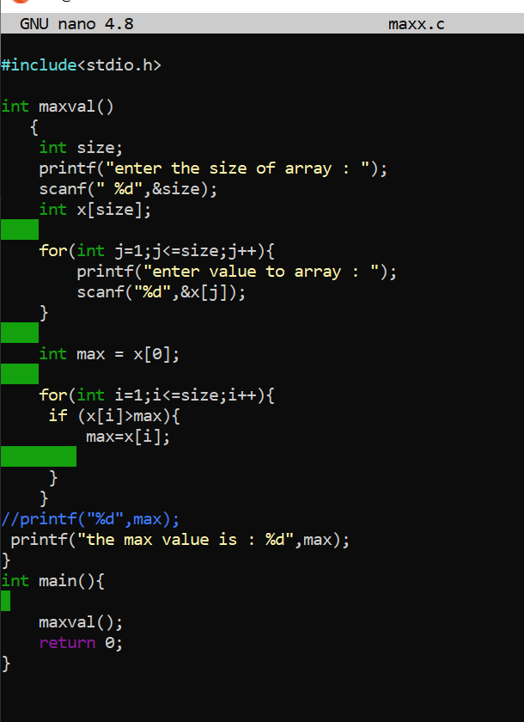

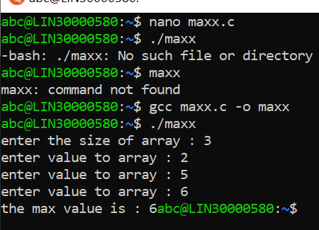

1. Extend the code given below to read N and a start value from the user to perform the given operations.

#define MAX 100

int main()

{

int arr[MAX] = {11,22,33};

}

Add the following functions choosing proper input, output and return.

1. init() - Use the inputs to initialize the first N elements of the array with N consequetive values starting with given start value .
2. update() – increment value of every element in the array
3. display() – display the contents of array
4. 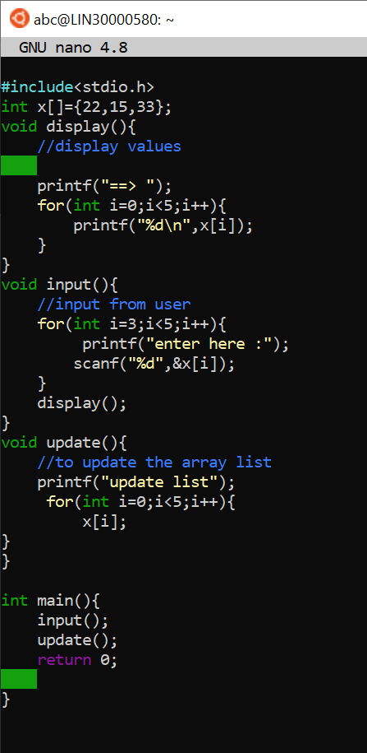

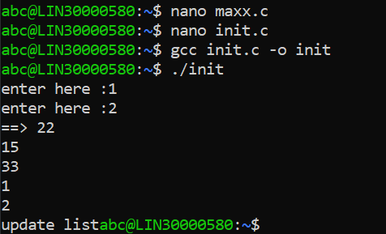

b

**2D, MultiDimensional Arrays**

1. Implement sort() to sort a given array. Refer the code snippet below.

int main()

{

char arr[]= “xaybz”;

sort(arr, sizeof(arr)/sizeof(arr[0]);

return 0;

}

**Ans-**

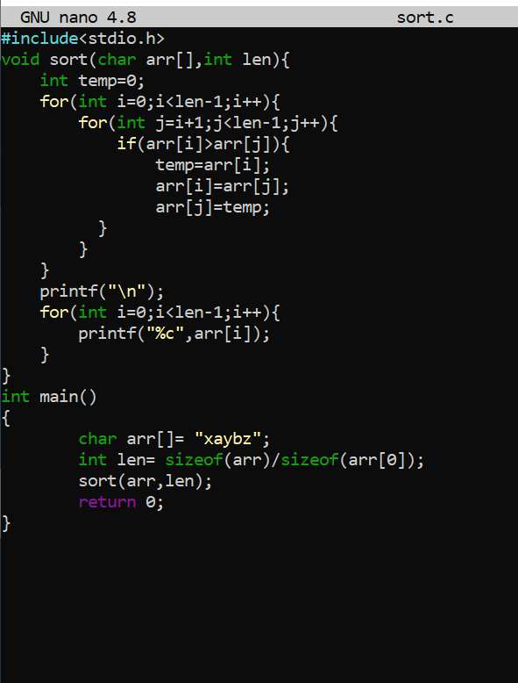

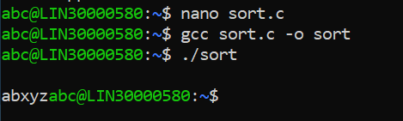

1. Refer the code snippet below.

int main()

{

char arr[][3] = {

sort(arr, sizeof(arr)/sizeof(arr[0]);

return 0;

}

Allow user to perform the following operations.

* 1. init() - initialize the array and return 0
  2. search_update() – search for a given element in a(rray and if found update it to given value and return 0 else return 1
  3. display() – traverse and display array contents

For the functions, pass array and other required arguments to functions and return as per requirement

